**SQL Queries**

**Business Questions:**

1. **What is the count of distinct cities in the dataset?**

**SQL Querie:**

SELECT COUNT(DISTINCT city) FROM salesdata;

**Output:**

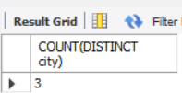

1. **For each branch, what is the corresponding city?**

**SQL Query:**

SELECT DISTINCT branch, city FROM salesdata;

**Output:**

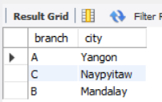

1. **What is the count of distinct product lines in the dataset?**

**SQL Query:**

SELECT DISTINCT product_line FROM salesdata;

**Output:**

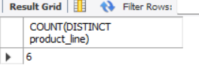

1. **Which payment method occurs most frequently?**

**SQL Query:**

SELECT payment_method, COUNT(*) Count FROM salesdata

GROUP BY payment_method

ORDER BY Count DESC

LIMIT 1;

**Output:**

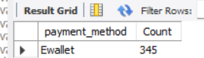

1. **Which product line has the highest sales?**

**SQL Query:**

SELECT product_line, SUM(total) Total_Sales FROM salesdata

GROUP BY product_line

ORDER BY Total_Sales DESC

LIMIT 1;

**Output:**

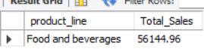

1. **How much revenue is generated each month?**

**SQL Query:**

SELECT YEAR(date) Year, Monthname, SUM(total) Revenue FROM salesdata

GROUP BY Year,Monthname

ORDER BY Revenue DESC;

**Output:**

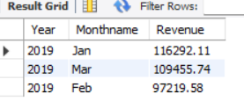

1. **In which month did the cost of goods sold reach its peak?**

**SQL Query:**

SELECT MONTH(date) Month, SUM(cogs) cogs_value FROM salesdata

GROUP BY Month

ORDER BY cogs_value DESC

LIMIT 1;

**Output:**

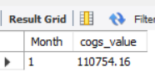

1. **Which product line generated the highest revenue?**

**SQL Query:**

SELECT product_line, SUM(total) Revenue FROM salesdata

GROUP BY product_line

ORDER BY Revenue DESC

LIMIT 1;

**Output:**



1. **In which city was the highest revenue recorded?**

**SQL Query:**

SELECT city, SUM(total) Revenue FROM salesdata

GROUP BY city

ORDER BY Revenue DESC

LIMIT 1;

**Ouput:**



1. **Which product line incurred the highest Value Added Tax?**

**SQL Query:**

SELECT product_line, ROUND(SUM(VAT),2) Tax_Value FROM salesdata

GROUP BY product_line

ORDER BY Tax_Value DESC

LIMIT 1;

**Output:**

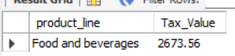

1. **For each product line, add a column indicating "Good" if its sales are above average, otherwise "Bad."**

**SQL Query:**

WITH Sales AS(

SELECT product_line, SUM(total) Total_sales

FROM salesdata

GROUP BY product_line)

SELECT *, CASE WHEN Total_sales>(SELECT AVG(Total_sales) FROM Sales) THEN "Good" ELSE "Bad" END AS Quality

FROM Sales;b

**Output:**

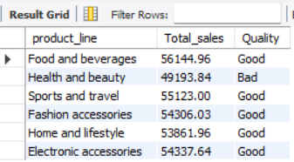

1. **Identify the branch that exceeded the average number of products sold.**

**SQL Query:**

WITH Branch_sales_count AS (

SELECT branch, count(*) product_count FROM salesdata

GROUP BY branch)

SELECT branch, product_count FROM Branch_sales_count

WHERE product_count> (SELECT AVG(product_count) FROM Branch_sales_count);

**Output:**



1. **Which product line is most frequently associated with each gender?**

**SQL Query:**

WITH gender_rank AS(

SELECT gender, product_line, COUNT(*) COUNT, RANK() OVER(PARTITION BY gender ORDER BY COUNT(*) DESC) RANKP FROM salesdata

GROUP BY gender, product_line)

SELECT gender, product_line,COUNT FROM gender_rank

WHERE RANKP=1;

**Output:**

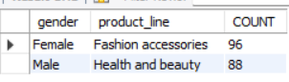

1. **Calculate the average rating for each product line.**

**SQL Query:**

SELECT product_line, ROUND(AVG(rating),1) Avg_rating FROM salesdata

GROUP BY product_line

ORDER BY Avg_rating DESC;

**Output:**

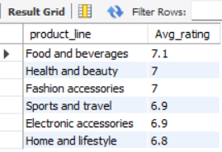

1. **Count the sales occurrences for each time of day on every weekday.**

**SQL Query:**

SELECT dayname, dayoftime, COUNT(*) AS sales_count

FROM salesdata

GROUP BY dayname, dayoftime

ORDER BY

CASE dayname

WHEN 'Mon' THEN 1

WHEN 'Tue' THEN 2

WHEN 'Wed' THEN 3

WHEN 'Thu' THEN 4

WHEN 'Fri' THEN 5

WHEN 'Sat’ THEN 6

WHEN 'Sun' THEN 7

END,

CASE dayoftime

WHEN 'Morning' THEN 1

WHEN 'Afternoon' THEN 2

WHEN 'Evening' THEN 3

END;

**Output:**

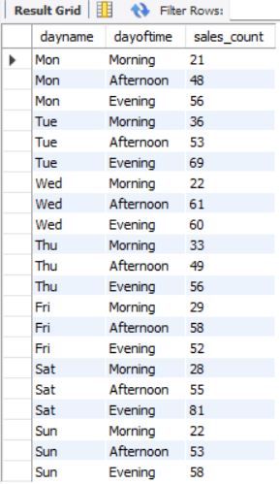

1. **Identify the customer type contributing the highest revenue.**

**SQL Query:**

SELECT customer_type, SUM(total) revenue

FROM salesdata

GROUP BY customer_type

ORDER BY revenue DESC

LIMIT 1;

**Output:**



1. **Determine the city with the highest VAT percentage.**

**SQL Query:**

SELECT city, SUM(VAT)/(SELECT SUM(VAT) FROM salesdata)*100 `Vat%` FROM salesdata

GROUP BY city

ORDER BY `Vat%` DESC

LIMIT 1;

**Output:**

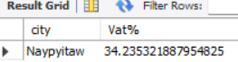

1. **Identify the customer type with the highest VAT payments.**

**SQL Query:**

SELECT customer_type, ROUND(SUM(VAT),2) VAT_Payment

FROM salesdata

GROUP BY customer_type

ORDER BY VAT_Payment DESC

LIMIT 1;

**Output:**

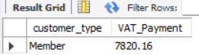

1. **What is the count of distinct customer types in the dataset?**

**SQL Query:**

SELECT COUNT(DISTINCT customer_type) Count_customer_type FROM salesdata;

Output:

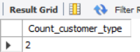

1. **What is the count of distinct payment methods in the dataset?**

**SQL Query:**

SELECT COUNT(DISTINCT payment_method) Count_payment_method FROM salesdata;

**Output:**

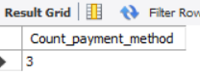

1. **Which customer type occurs most frequently?**

**SQL Query:**

SELECT Customer_type, COUNT(*) AS Frequency

FROM salesdata

GROUP BY Customer_type

ORDER BY Frequency DESC

LIMIT 1;

**Output:**



1. **Identify the customer type with the highest purchase frequency.**

**SQL Query:**

SELECT Customer_type, SUM(quantity) purchase_frequency

FROM salesdata

GROUP BY Customer_type

ORDER BY purchase_frequency DESC

LIMIT 1;

**Output:**



1. **Determine the predominant gender among customers.**

**SQL Query:**

SELECT gender, COUNT(*) gender_count FROM salesdata

GROUP BY gender

ORDER BY gender_count DESC

LIMIT 1;

**Output:**



1. **Examine the distribution of genders within each branch.**

**SQL Query:**

SELECT branch, gender, COUNT(*) count_no FROM salesdata

GROUP BY branch, gender

ORDER BY branch ;

**Output:**

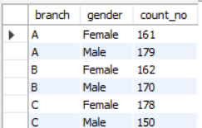

1. **Identify the time of day when customers provide the most ratings.**

**SQL Query:**

SELECT dayoftime, COUNT(rating) count_rating FROM salesdata

GROUP BY dayoftime

ORDER BY count_rating DESC

LIMIT 1;

Output:



1. **Determine the time of day with the highest customer ratings for each branch.**

**SQL Query:**

WITH Rating_rank AS(

SELECT branch, dayoftime, MAX(rating) Highest_Rating, RANK() OVER(PARTITION BY branch ORDER BY MAX(rating) DESC) rank_branch FROM salesdata

GROUP BY branch, dayoftime

ORDER BY branch, rank_branch)

SELECT branch, dayoftime, Highest_Rating FROM Rating_rank

WHERE rank_branch=1;

**Output:**

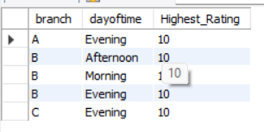

1. **Identify the day of the week with the highest average ratings.**

**SQL Query:**

SELECT dayname, ROUND(AVG(rating),2) Avg_rating FROM salesdata

GROUP BY dayname

ORDER BY Avg_rating DESC

LIMIT 1;

**Output:**



1. **Determine the day of the week with the highest average ratings for each branch.**

**SQL Query:**

WITH Avg_ratings AS (

SELECT branch, dayname, ROUND(AVG(rating),2) Avg_rating FROM salesdata

GROUP BY branch, dayname

ORDER BY branch),

Rank_Avg_ratings AS(

SELECT *, RANK() OVER(PARTITION BY branch ORDER BY Avg_rating DESC) rank_rating FROM Avg_ratings)

SELECT branch, dayname, Avg_rating FROM Rank_Avg_ratings

WHERE rank_rating =1;

**Output:**

